**Non-proliferative diabetic retinopathy detection using feature fusion technique**

*Author 1, Author 21, Author 31

1Address 1

1*Email id

2 Address 2

2Email id

* Corresponding Author

**Abstract.** Diabetic Retinopathy (DR) is a chronic disease in the eye due to blood leakages which causes vision impairment and can be identified on the surface of the retina. Diabetic patients are the most common subject to this disease, and ignorance to it can result in permanent visual damage and eventual blindness. DR falls in two categories: Proliferative Diabetic Retinopathy (PDR) and Non-Proliferative Diabetic Retinopathy (NPDR). Non-Proliferative DR is the most common form of DR whereas Proliferative DR is the severe stage of DR which causes the blood vessels to close off. DR can be detected in its early stages by the Red lesions i.e., microaneurysms and hemorrhages. In this paper we implement a method of detecting red and bright lesions combined together by fusion for detection of NPDR form. The proposed methodology uses fundus images as its input and employs modified approach to extraction of retinal blood vessels and median filtering. To train the model, multiclass Support Vector Machine classifier is implemented using the extracted features. The method is tested on 1928 fundus images from ‘KAGGLE APTOS’, DIAREDB1 with 89 images and103 images from ‘IDRiD’ dataset. The results that are experimentally obtained by applying this algorithm by applying it on the datasets ‘DIAREDDB1’, ‘IDRiD’ and ‘KAGGLE APTOS’ and obtained accuracies of 95.3%, 97.32% and 97.23% on the respective datasets. The results have been highly satisfactory as well as having very low computational time.

**Keywords:** Fusion, Red lesion, Bright lesion, Diabetic Retinopathy, Adaptive Histogram equalization, Support Vector Machine.

**1 Introduction**

The advancement in computer technologies and specifically in Artificial Intelligence and Machine Learning has become one of the most important factors in development of medical field and its resources. Diabetic Retinopathy is complication which causes damages to the blood vessels of the light sensitive tissue of the back of the eye called retina. DR has fatal consequences if it is not dealt with for a long period of time, one of them is permanent blindness.

The paper proposes an algorithm to detect Diabetic Retinopathy using fusion technique which is a combination of red and bright lesions. The automated system for prediction of Diabetic Retinopathy uses color fundus images obtained by fundus camera as its input. The microaneurysms are tiny red dots that appear in the eye and due to vascular leakage are surrounded by yellow rings. Microaneurysms causes swelling of tiny retinal blood vessels and release fluid into the retina. They do not have any effect on the visual abilities of a person and have no other symptoms. The blot hemorrhages appear due to the ruptured micro-aneurysms in the retinal layer. Due to the blots, the blood flow to the retina reduces considerably, leading to PDR.

The majority of hard exudates are found in the macular region, and as the lipids coalesce and extend into the central macula (fovea), vision can be severely harmed. The feature extraction process results in the extraction of a set of 5 features which are subsequently used in the Multiclass Support Vector Machine classifier training of the training dataset. The dataset is mixed with true and false lesion objects.

**2 Related work**

The following literature presents various methods of detecting diabetic retinopathy using red lesions using fundus images. Balazs Harangi [1] used a combination of CNN and hand-crafted features to detect the disease. In which he got an accuracy of 90.07% but the major disadvantage of the model is classification of images with different positions. Dr. D. K. Kirange [2] used Gabor features and Naïve Bayes Classification for the detection of DR where he got an accuracy of 74.46% and precision of 78.3%. The problem in the model was Naïve Bayes assumes that all features are not dependent and this algorithm faces the 'zero-frequency problem' where it assigns zero probability to a categorical variable. Farrikh Alzami [3] used fractal dimension feature, which help them characterize the retinal vasculature in the DR predictions which gave him an accuracy of 91.6% but Random forest models are not all that interpretable and for very large datasets it can take lot of memory.

Akhilesh Kumar Gangwar [4] used Inception-ResNet-v2 and added a custom block of CNN layers on top of Inception-ResNet-v2 for building the hybrid model and presented an automated system for the detection of DR and got an accuracy of 82.18%. Mohamed Shaban [5] used a deep Convolutional Neural Network (CNN) with 18 convolutional layers and 3 fully connected layers for the prediction of DR but the problem with CNN is that it doesn’t encode the position and orientation of the object and lacks of ability to be spatially invariant to the input data for which he got an accuracy of 88%. Our proposed model used SVM multiclass classifier model to the detect the diabetic retinopathy using SVM to get an accuracy of 93.3% in IDRID and 94.5% in Kaggle Aptos dataset with 78.5% and 78.4% of sensitivity and precision in IDRID dataset and 80.6% and 75.6% of sensitivity and precision in Kaggle Aptos dataset.

**3 Proposed model**

In this paper, the proposed method detects presence of red lesions and bright lesions using the images from fundus camera as its input. Fig. 1 shows the flow diagram for the proposed methodology.

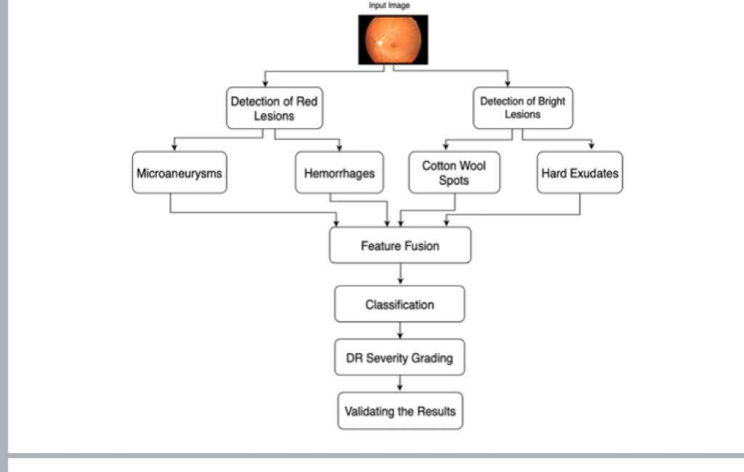

**Fig. 1.** Flow of the proposed model

**3.1 Pre-Processing** is needed in order to remove any noise, get a better contrast and so that a more consistent dataset with only relevant features is obtained. In Pre-processing the first step involved is to filter and convert the fundus images from a 2D matrix to a 3D matrix in order to get 3 planes (red, blue and green) so as to make it easier to perform morphological operations on the image. After the conversion to 3D matrix, a median filter is applied to remove additional noise or dilutions from the image. After the application of filter on the images, the green plane is extracted to clear the dark spots of red lesions, high of red lesions and low value of other lesions. In order to spot the lesions, based on its properties of color it having low pixel in the green plane, resulting in dark spots in the green channel providing with the best contrast for the images. The green channel shows the proper numbers and dimensions including the major axis lengths where the region props are present.

The lesions detection algorithm steps:

* + - 1. Adaptive threshold.
      2. Filtering operations through Morphological operations.

The method starts firstly by applying the adaptive threshold algorithm to the improved image with sensitivity level of 0.15 for red and 0.85 for bright lesion, this image is then converted to morphological operations which tries to filter any noise and perform area-based rejection to the output image as seen in Fig. 2 depicts the eye before and after the preprocessing stage. As we can see the right picture has a better clarity than the left picture. So, in total 2 filtering techniques were used.

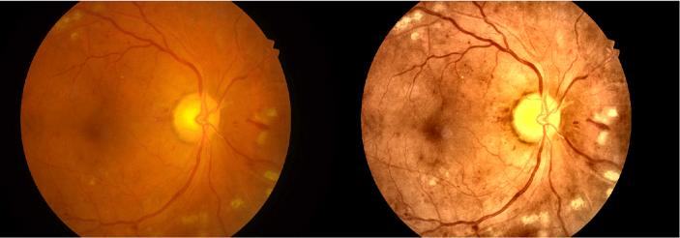

**Fig. 2.** Enhanced figure of fundus image after applying filtering methods

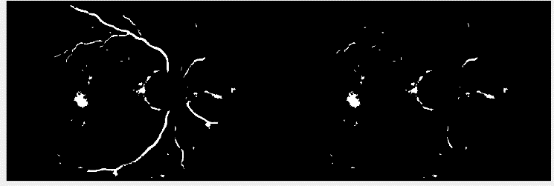**3.2 Extraction of retinal blood vessels**. Due to the blood vessels being the widest at the origin as well as being darker in the green channel, the process of detecting lesions after the removal of blood vessels is easier. Blood vessels are widest near the point of lesions and become narrow as we move away from that point. The grey level profile in the image is estimated using Gaussian function. But, due to the random nature of the blood vessels, performing morphological operations to extract feature is difficult and therefore Matched filtering is used to determine the character of the feature [6]. The gaussian kernel of the matched filtering is dependent on the value of variance parameter, sigma (µ). Results have shown that the value of this parameter for human retinal blood vessels ranges from 1.5 to 3. The classical approach uses just one value of µ whereas in our approach, we use two values for µ: 1.5 and 2. This is done in order to extract wider vessels as larger value extract wider vessels. Due to the random orientation of the blood vessels as mentioned before, the kernel rotates from 0º to 180º through an angle of 15º. The pre-processed image now has 12 kernels for the matched filtering. Each pixel of the image has 12 responses from the kernel, and the resulting image of the matched filtering is obtained by using the best value (maximum) for each pixel from the 12 responses. Similarly, we use the values 1.5 and 2 to obtain two output images. A threshold value has been set to separate the enhanced blood vessels. To search the threshold required, we use automatic thresholding technique. A co-occurrence matrix stores the derived threshold values when grey level intensity ‘x’ has a close by value ‘y’. The co-occurrence matrix is split into four quadrants ‘A’ to ‘D’ using the threshold value ‘th’.

**Fig. 3.** Removing noise and other disturbances and getting the final lesions

**3.3 Candidate lesions detection and classification** Candidate lesion detection has a multitude of approaches which perform morphological operations using techniques like h-maxima transformation, thresholding, region growing etc. We employ the morphological operation of opening and then closing on the length filtered images and local entropy threshold of 0.15 for red and 0.85 for bright lesions. The preprocessing operations result in a loss of a few lesions near the vessel segment, which are recovered by the sequential morphological operations of abrasion and dilation, performed on the image. The recovered lesions are added to the images and are now detected. The resulting image was cleaned to obviate noise as seen in Fig. 3. The sensitivity level for the adaptive threshold is below 0.15 for red and 0.85 for bright. However, when extracting red regions, the veins was also extracted; this is often the most motivation to feature the anomaly rejection algorithm which tries to filter the veins by having a few ratio thresholds, and an expand threshold which measures how the tested object fills its corresponding bounding box. To distinguish the lesions and non-lesions the proposed methodology applies multiclass Support Vector Classifier. SVM segregates the different classes using a hyper-plane in the feature space in the given image. This segregation window is maximized in order to best separate the categories using the multiclass SVM.

**4 Fusion**

Combining classifiers can be achieved in a number of ways. The most common method is classifier fusion, which assumes competitive classifiers and assumes that all classifiers contribute to the final decision. The fundamental method is classifier fusion, which considers that everyone classifier make contributions to the ultimate selection, assuming aggressive classifiers. Fusing the results from both the architectures by averaging the results from both the architectures and taking the max.

**5 Results and discussions**

We analyze and compare the performance of our model against the existing implementations of detection of Diabetic Retinopathy using Red lesions on the datasets ‘KAGGLE APTOS’ and ‘IDRiD’. The output parameters for comparison are: (i) Accuracy (ii) Sensitivity and (iii) Precision. The model proposed by us has better output parameters as compared to the existing models. The performance metrics to analyze the model is defined in terms of True Positives (TP), True Negatives (TN), False Positives (FP) and False Negatives (FN). These metrics are used to calculate True Positive Rate and False Positive Rate through which we are able to derive the ROC curves for the proposed model. The ROC curve represents the proposed model on the two datasets and tests the multiclass-SVM classifier used in the model.

TP = (TP/TP+FN)

FP = (FP/FP+TN)

The steepness of the curve is ideal to maximize the true positive rate and minimizes the false positive rate. Quantitative results on the idrid and kaggle aptos datasets. The reported results compare the parameters accuracy, sensitivity and precision between the existing models and proposed model respectively.

1. quantitative results on the idrid and kaggle aptos datasets. the reported results compare the parameters accuracy, sensitivity and precision between the existing models and proposed model respectively.

|  |  |  |  |
| --- | --- | --- | --- |
| **IDRID DATASET** | | | |
|  | **Accuracy** | **Sensitivity** | **Precision** |
| Eman AbdelMaksoud [7] (2020) | 90.2% | - | - |
| Zhan Wua [8] (2020) | 56.19% | 64.21% | - |
| Balazs Harangi [9] (2019) | 90.07% | - | - |
| Dr. D. K. Kirange [10] (2020) | 74.46% | - | 78.3% |
| Farrikh Alzami [11] (2019) | 91.6% | - | - |
| **Proposed Model** | **97.23%** | **70.5%** | **70.4%** |
| **KAGGLE DATASET** | | | |
| Sara Hosseinzadeh Kassani [12] (2019) | 83.09% | - | - |
| Akhilesh Kumar Gangwar [13] (2020) | 82.18% | - | - |
| Mohamed Shaban [14] (2020) | 88% | - | - |
| **Proposed Model** | **97.32%** | **90.2%** | **89.2%** |

The above-mentioned table shows the comparison between the accuracy, sensitivity and precision in two different datasets. It clearly shows that our proposed model has better results than the earlier existing models. The highest accuracy achieved in IDRID dataset is 97.23% and in KAGGLE dataset is 97.32%. This shows our model can perform and show better results.

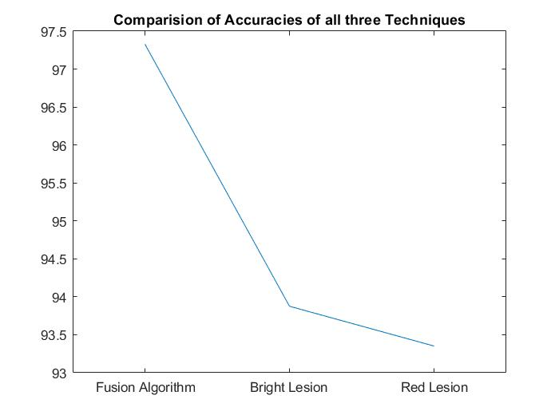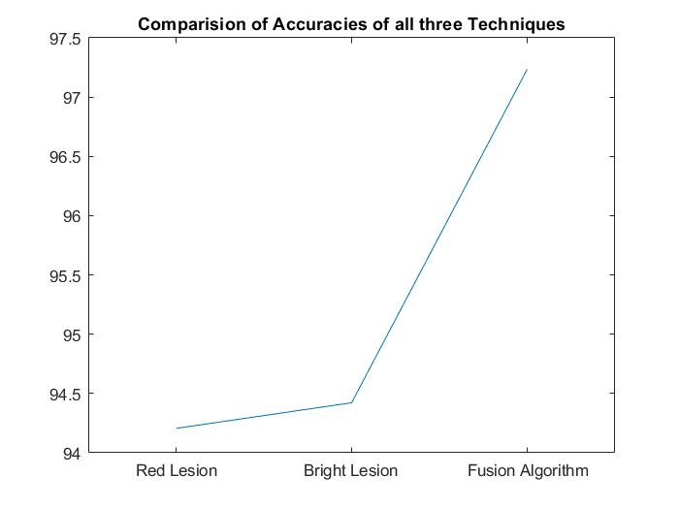

**Fig. 4.** (a) Comparison curve for accuracies on IDRID dataset, (b) Comparison curve for for accuracies on KAGGLE APTOS dataset

The results presented in Fig. 4 (a) and Fig. 4 (b) expresses how accurate the proposed fusion model as compared to the accuracies of the red and bright lesion techniques of DR detection. It highlights that the fusion model outperforms the traditional approach of red and bright lesion by 3.4% and 3.1% on the IDRiD and Kaggle APTOS datasets respectively.



**Fig. 5.** (a) Training Set plot of count feature for IDRiD, (b) Training Set plot of count feature for KAGGLE APTOS

A graph to represent the count for the features per image for training set of both datasets is plotted as shown in Fig. 5 (a) and Fig. 5 (b) for the datasets IDRiD and KAGGLE APTOS. An automated algorithm using for loop is applied to the number of lesions extracted for each image in section 3.2 and plotted against the image ID (the image for which the lesion was extracted), represented in as a graph as Fig. 5 (a) and Fig. 5 (b) for IDRiD and KAGGLE APTOS datasets respectively.

**5 Conclusion**

DR **detection can** prevent blindness.Ophthalmologists use o**phth**al**moscopes** **to observe** various **signs** **such as b**l**ood** vessels **and** microaneurysms **to ass**e**ss** the sta**g**e of **DR**.Now**,** **one** day digital imaging **is essen**t**ial for** automat**ed DR methods. They are very important to determ**in**e** the **s**t**age** of DR a**nd cu**re **in time. This is usually** very necessary **because in some cases, treatment cannot be per**for**med even in the late stages of DR. It is only feasible to combine the** detection of **c**haracteristic lesions with **the fusion of single lesion data. The** accuracy **of identifying all lesions is mo**re than 80%. **T**he new classification level **is usu**a**lly** defined as a r**eliable** framework **for detec**t**ing** the presence of DR. Fusion method proves to be the simplest out of all the techniques used for predicting the diabetic retinopathy using fundus images.

**References**

1. Balazs Harangi, Janos Toth, Agnes Baran, Andras Hajdu; “Automatic screening of fundus images using a combination of convolutional neural network and hand-crafted features,” 41st Annual International Conference of the IEEE Engineering in Medicine and Biology Society (EMBC), (2019).

2. Dr. D. K. Kirange, Dr. J.P. Chaudhari, Dr. K. P. Rane, Dr. K. S. Bhagat, Dr. Nandini Chaudhri, “Diabetic Retinopathy Detection and Grading Using Machine Learning,” International Journal of Advanced Trends in Computer Science and Engineering, Volume 8, No.6, pp.3570-3576, November – December, (2019).

3. Farrikh Alzami, Rama Aria Megantara, Ahmad Zainul Fanani, Abdussalam, “Diabetic Retinopathy Grade Classification based on Fractal Analysis and Random Forest,” International Seminar on Application for Technology of Information and Communication (iSemantic), (2019).

4. Akhilesh Kumar Gangwar, Vadlamani Ravi, “Diabetic Retinopathy Detection Using Transfer Learning and Deep Learning,” Evolution in Computational Intelligence, pp.679-689, (2020).

5. Mohamed Shaban, Zeliha Ogur, Ali Mahmoud, Andrew Switala, Ahmed Shalaby, Hadil Abu Khalifeh, Mohammed Ghazal, Luay Fraiwan, Guruprasad Giridharan, Harpal Sandhu, Ayman S. El-Baz, “A convolutional neural network for the screening and staging of diabetic retinopathy,” Public Library of Science ONE, (2020).

6. Vijay M Mane, Ramish B Kawadiwale, D. V. Jadhav, “Detection of Red lesions in diabetic retinopathy affected fundus images,” IEEE International Advance Computing Conference, (IACC), (2015).

7. Eman Abdel Maksoud, Sherif Barakat, Mohammed Elmogy, “A comprehensive diagnosis system for early signs and different diabetic retinopathy grades using fundus retinal images based on pathological changes detection,” Computers in Biology and Medicine, pp.126, November, (2020).

8. Zhan Wu, Gonglei Shi, Yang Chen, Fei Shi, Xinjian Chen, Gouenou Coatrieux, Jian Yang, Limin Luo, Shuo Li, “Coarse-to-fine classification for diabetic retinopathy grading using convolutional neural network,” Artif. Intell. Medicine, pp.108, August, (2020).